Connecting to d02 & s02 Worker Machines in Windchill NA
Purpose:
This document outlines the steps for starting the d02 and s02 Worker Machines in Windchill NA. These workers play a vital role in system task processing, and any downtime can significantly affect overall operations.

Quick Reference Table:
Worker | Primary Action | If Primary Action Fails
d02 | Go to Worker Agent Administration and click the green flag to start the d02 Worker | - Connect via Remote Desktop → Once connected, WorkerDaemon.exe starts automatically  - Return to Worker Agent Administration and click the green flag again.
s02 | Go to Worker Agent Administration and click the green flag to start the s02 Worker | - Connect via Remote Desktop → Once connected, WorkerDaemon.exe starts automatically  - Return to Worker Agent Administration and click the green flag again.

- If d02 is unavailable, follow the steps outlined below.

Step 1- Go to the Worker Agent Administration, click on green flag to start the d02 Worker.
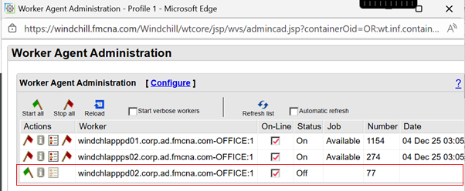
Step 2- If step 1 fails, follow the below steps to start d02, we have to connect to the worker machine to start the Worker Deamon.
- Check the list of servers. Refer system_catalogue.xlsx to get the Windchill NA Worker Machine hostname as below –
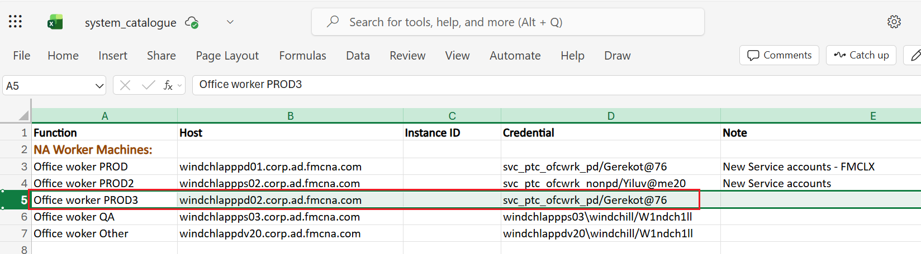
- Search for Remote Desktop in the VDI.
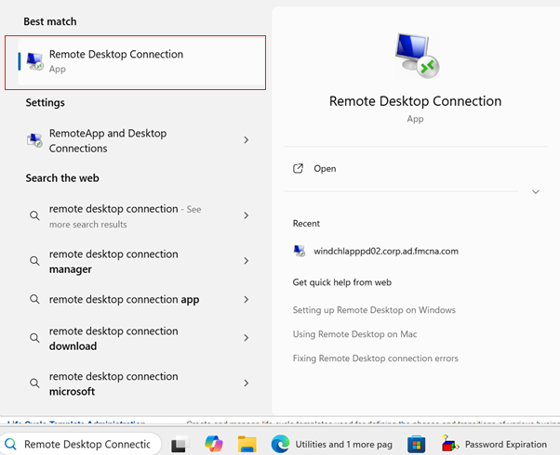
- Enter credentials from the system catalogue sheet for d02 Worker and click on connect.
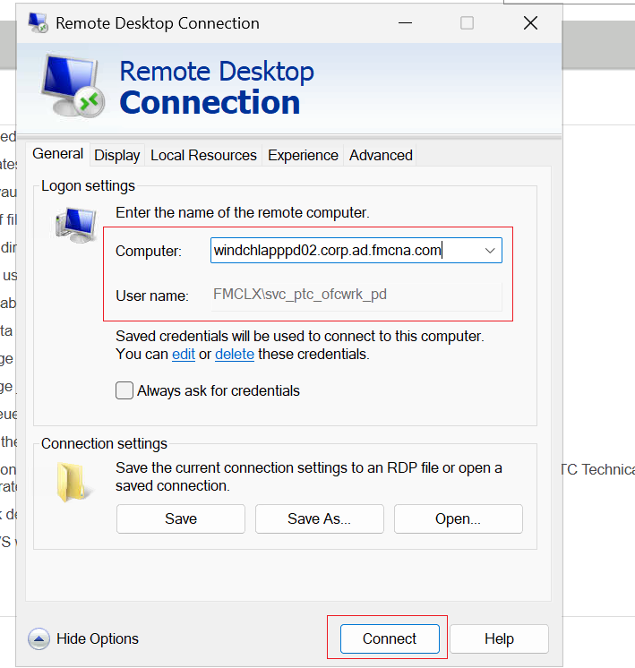
- Enter Password from system catalogue sheet for d02 Worker Machine.
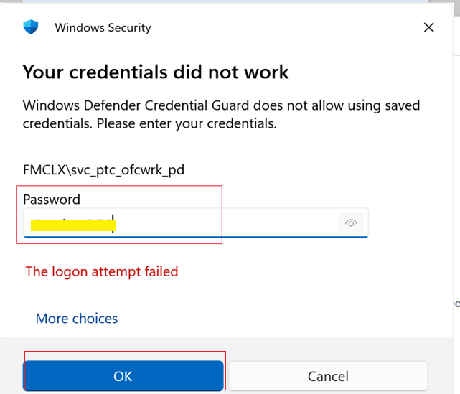
- Now we are connected to the server & we don’t need to start the WorkerDaemon.exe manually, it will automatically start as soon as you connect to the worker machine.
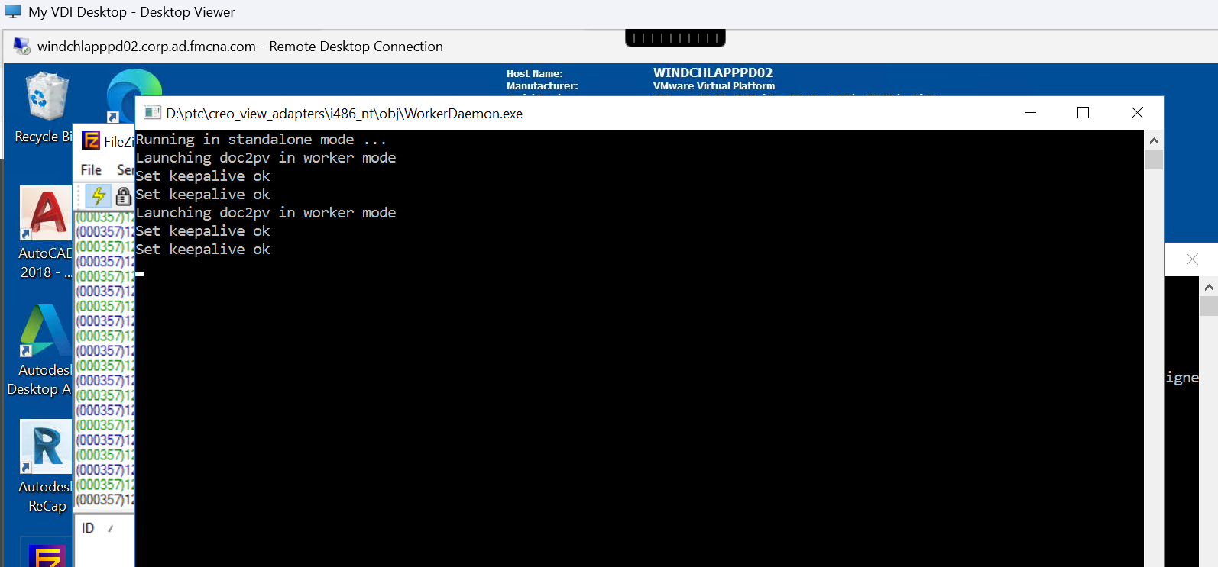

- Then, go back to the Worker Agent Administration and click on green flag to start the d02 Worker, it will start.
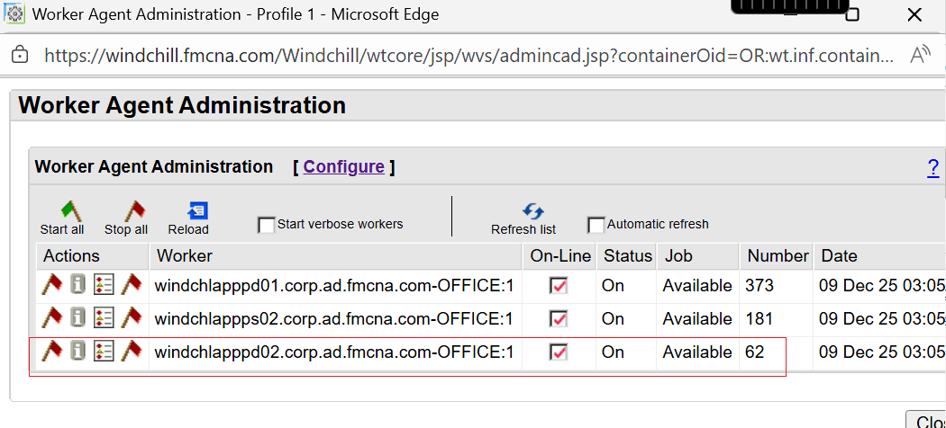
- If s02 is unavailable, follow the steps outlined below.
Step 1- Go back to the Worker Agent Administration click on green flag start the s02 Worker.
Step 2- If step 1 fails, follow the same steps as for d02.

